- Read about the difference between window, screen and document in javascript
Ans.
Window is the main JavaScript object root, aka the global object in a browser, and it can also be treated as the root of the document object model. You can access it as a window.
window.screen or just screen is a small information object about physical screen dimensions.
window.document or just document is the main object of the potentially visible (or better yet: rendered) document object model/DOM.
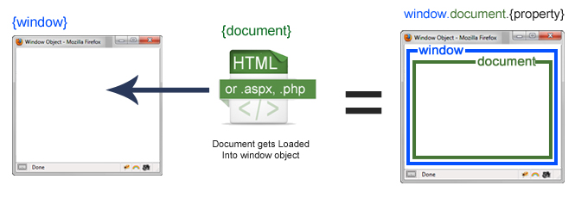
- window is the execution context and global object for that context's JavaScript
- document contains the DOM, initialized by parsing HTML
- screen describes the physical display's full screen

Window
Each browser tab has its own top-level window object. Each <iframe> (and deprecated <frame>) element has its own window object too, nested within a parent window. Each of these windows gets its own separate global object. window.window always refers to window, but window.parent and window.top might refer to enclosing windows, giving access to other execution contexts. In addition to document and screen described below, window properties include
- setTimeout() and setInterval() binding event handlers to a timer
- location giving the current URL
- history with methods back() and forward() giving the tab's mutable history
- navigator describing the browser software

document
Each window object has a document object to be rendered. These objects get confused in part because HTML elements are added to the global object when assigned a unique id. E.g., in the HTML snippet
<body> <p id="holyCow"> This is the first paragraph.</p> </body>
the paragraph element can be referenced by any of the following:
- window.holyCow or window["holyCow"]
- document.getElementById("holyCow")
- document.querySelector("#holyCow")
- document.body.firstChild
- document.body.children[0]

screen
The window object also has a screen object with properties describing the physical display:
- screen properties width and height are the full screen
- screen properties availWidth and availHeight omit the toolbar
The portion of a screen displaying the rendered document is the viewport in JavaScript, which is potentially confusing because we call an application's portion of the screen a window when talking about interactions with the operating system. The getBoundingClientRect() method of any document element will return an object with top, left, bottom, and right properties describing the location of the element in the viewport.

